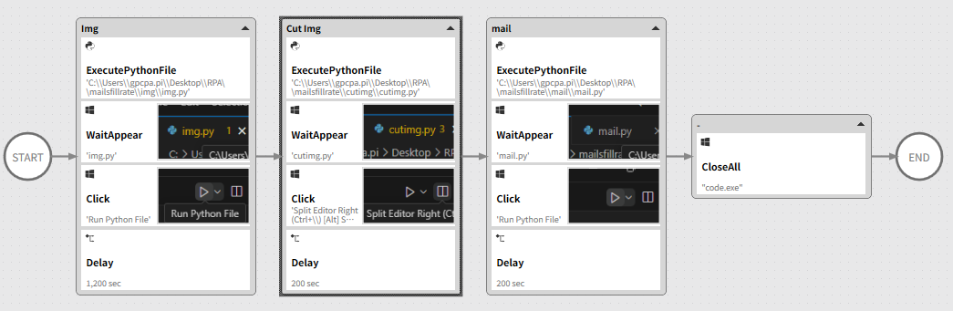

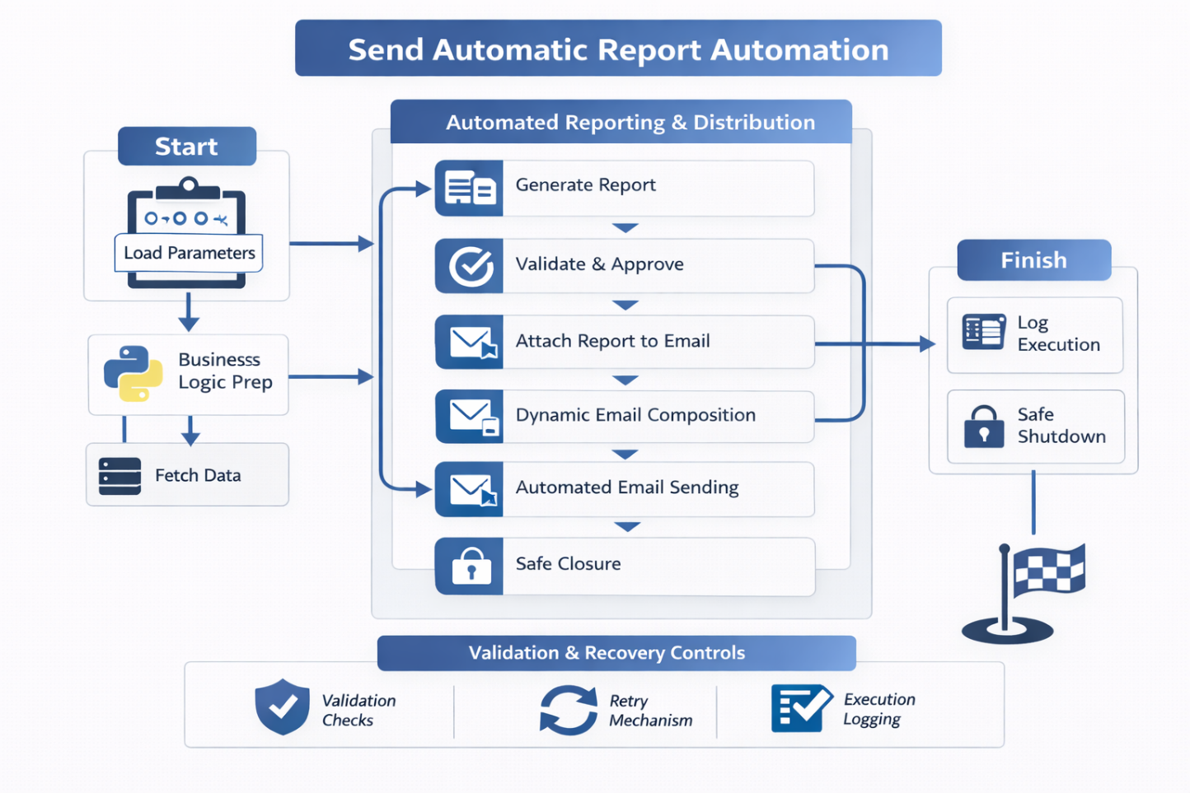

Executive Summary
Enterprise-grade RPA solution that automates the generation, validation, and distribution of operational reports, replacing manual preparation and email sending with a controlled, scheduled, and auditable workflow.
The automation ensures timely delivery, data consistency, and full traceability across stakeholders.

🎯 Business Problem
The report distribution process was manual and presented several inefficiencies:
- Manual data extraction and report preparation
- High dependency on individual availability
- Risk of sending outdated or incorrect data
- Repetitive email composition and attachment handling
- No execution trace or delivery confirmation
This caused delays, inconsistencies, and unnecessary operational overhead.

🧠 Solution Overview
A fully automated reporting solution was designed to extract data, build standardized reports, validate results, and send emails automatically to predefined recipients.
The solution integrates Python business logic, file handling, validation checkpoints, and enterprise email automation.

🖼 RPA Orchestration Breakdown
- Initialization & Configuration
  - Load report parameters (recipients, schedule, formats)
  - Clean working directories and prepare execution context
- Data Extraction
  - Retrieve source data (SAP, Excel, or databases)
  - Validate data availability and integrity
- Report Generation
  - Build standardized Excel / PDF reports
  - Apply formatting and naming conventions
- Validation & Approval Logic
  - Verify report completeness and consistency
  - Conditional execution based on validation results
- Automated Email Distribution
  - Attach generated reports
  - Dynamic subject and email body
  - Send to defined stakeholder groups
- Logging & Safe Closure
  - Save execution logs
  - Archive generated files
  - Controlled process shutdown

📊 Results & Business Impact
- Elimination of manual reporting tasks
- On-time and consistent report delivery
- Reduced human error risk
- Improved transparency and auditability
- More time available for value-added analysis

🔍 Before vs After
Before
- Manual data handling
- Repetitive report creation
- Manual email sending
- Dependency on individuals
- No execution trace
After
- Fully automated reporting flow
- Standardized and validated outputs
- Automatic email distribution
- Deterministic execution
- Full traceability and logs

🧩 Key Features
- End-to-end automated report generation
- Configurable schedules and recipients
- Validation checkpoints before sending
- Standardized file formats and naming
- Execution logging and archiving

🛠 Tech Stack
- Python (data processing, report generation)
- RPA Orchestration Platform
- Excel / PDF automation
- Email automation (SMTP / enterprise mail)
- File system management

🧠 Challenges & Design Decisions
- Data consistency risk → Implemented validation before sending
- Manual dependency → Fully automated scheduling and delivery
- Version control → Standardized naming and archiving
- Operational reliability → Defensive execution and logging

👤 My Role
- RPA Solution Architect
- Designed end-to-end reporting automation
- Defined validation and delivery logic
- Implemented report generation and email automation
- Ensured enterprise-grade reliability

🚀 Why This Project Matters
This project highlights how RPA can institutionalize reporting, ensuring reliability, consistency, and scalability while eliminating low-value repetitive work and reducing operational risk.

